# MODULE1

# (HTML)

1. **Are the HTML tags and elements the same thing?**

**ANS =** NO, The HTML tags and elements are not same thing.

E. g.= <h1 >This is the Heading .</h1> The above example is called elements. F. g.=<h1></h1>

The above example is called tags.

**EX: opening & closing tags:**

**1.**<h1></h1> to <h6></h6> (Define heading for whole html page)

**2.**<title></title> (define the title of HTML documents)

**3.**<p></p> (defines paragraph)

**4.**<div></div> (define division in HTML documents)

**EX: Self closed Tags:**

**1.**<br> (break the line)

**2.**<hr> (horizontal line)

**ELEMENTS:** elements holds the content an HTML elements is defined by start tag.some content & an end tag.

EX: <start tag>content…..<End Tag>

<h1>Heading</h1>

<p>paragraph </p>

# What are tags and attributes in HTML?

**ANS =** Tags are used to start of an HTML element and they are usually enclosed in angle brackets. An example of a tag is:

<h1>.

<h1 class=”heading”></h1>

In the above example the “class” is called attributes.

Ex. <tag attribute=”myimage.jpg”>

1. **What are void elements in HTML?**

**ANS =** The void elements are those elements who has a starting tag but not contain the ending tag.

Example of void elements : [<br>](https://www.geeksforgeeks.org/html-brgt-tag/), [<hr>](https://www.geeksforgeeks.org/html-hr-tag/), [<img>](https://www.geeksforgeeks.org/html-img-tag/), [<input>](https://www.geeksforgeeks.org/html-input-tag/), [<link>](https://www.geeksforgeeks.org/html-link-tag/), [<meta>](https://www.geeksforgeeks.org/html-meta-tag/).

# What are HTML Entities?

**ANS =** In a HTML we can use < > as a &It; &gt; for non brecking space we can use &nbsp; so &and ; its called HTML Entities.

Result Description EntityName Entity Number

Non-breaking space &nbsp; &#160;

< less than &1t; &#60;

**> greater than &gt; &#62;**

**& ampersand &amp; &#38;**

“ double quotation mark &quot; &#34;

, single quotation mark (apostrophe) &apos; &#39

# What are different types of lists in HTML?

**ANS =** There are three types of lists in HTML.

1. ordered list - An ordered list starts with the <ol> tag. Each list item starts with the <li> tag.
2. Unordered list - An unordered list starts with the <ul> tag. Each list item starts with the <li> tag.
3. Description list-The <dl> tag defines the description list, the <dt> tag defines the term (name), and the <dd> tag describes each term.

**Example code:**

<!DOCTYPE html>

<html>

<body>

<h2>An unordered HTML list <h2>

<ul>

<li>Coffee</li>

<li>Tea</li>

<li>Milk</li>

</ul>

</body>

</html>

**RESULT:**An unordered HTML list

**. coffee**

**. Tea**

**. Milk**

**6.what is the class attribute in HTML?**

**ANS=** the class attribute is give the classname HTML elemets. We use . in a css to specify a class

# 7.what is the difference between the ‘id’ attribute and the ‘class’ attribute of HTML elements?

**Ans=** we can use . to specify a class attribute and use the # to specify a id attribute. We can use same class but cannot use same id attribute. This is the major difference between class and id attribute.

# 8.what are the various formatting tags in HTML?

**ANS=** There are the various formatting tools in HTML.

<b> - Bold text

<i> - Italic text

<u> - Underline text

<strong> -Important text

<em> - emphasized text

<mark> - Marked text

<del> - delete text

<ins>- insert text

<sup> - superscript text

<sub> - subscript text

# How is cell padding different from cell spacing?

**ANS =** Cell padding defines the space between a table cell's border ans Cellspacing defines the space between individual cells.

|  |  |  |
| --- | --- | --- |
| **Parameters** | **Cellpadding** | **Cellspacing** |
| Purpose | Cellpadding basically defines the space present between a table cell’s border and the content present in it. | Cellspacing basically defines the space present between individual adjacent cells. |
| Process of Creation | One can create it using the tag of HTML <table>, but it sets the type attribute to cellpadding. | One can create it using the tag of HTML <table>, but it sets the type attribute to cellspacing. |
| Effectiveness | It is very effective as compared to cellspacing. Thus, it is very widely used. | It is comparatively less effective than cellpadding. |

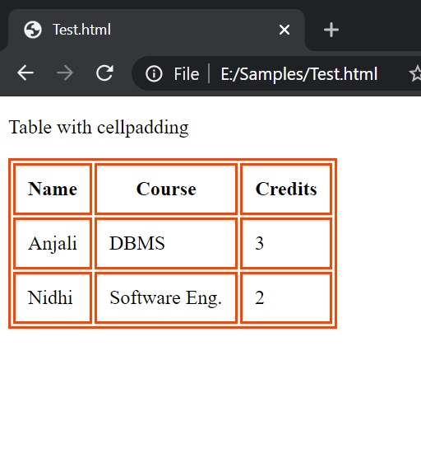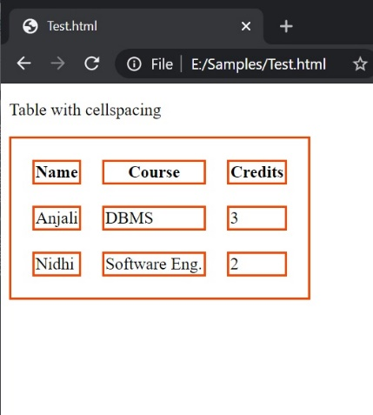

1. **How can we club two or more rows or columns into a single rows and column in an HTML table?**

**ANS=** we can club two or more rows using rowspan=”” attribute.

For example:

<html lang="en">

<head>

<meta charset="UTF-8">

<meta http-equiv="X-UA-Compatible" content="IE=edge">

<meta name="viewport" content="width=device-width, initial-scale=1.0">

<title>Document</title>

</head>

<style>

table, th,

td {

border: 2px solid red;

}

</style>

<body>

<table>

<tr>

<th>no.</th>

<th>Name</th>

<th>city</th>

</tr>

<tr>

<td>1</td>

<td>saloni</td>

<td rowspan="2">ahmedabad</td>

</tr>

<tr>

<td>1</td>

<td>neel</td>

</tr>

<tr>

<td>1</td>

<td>sapna</td>

<td>baroda</td>

</tr>

<tr>

<td>1</td>

<td>chintan</td>

<td>surat</td>

</tr>

</table>

</body>

</html>

Output:

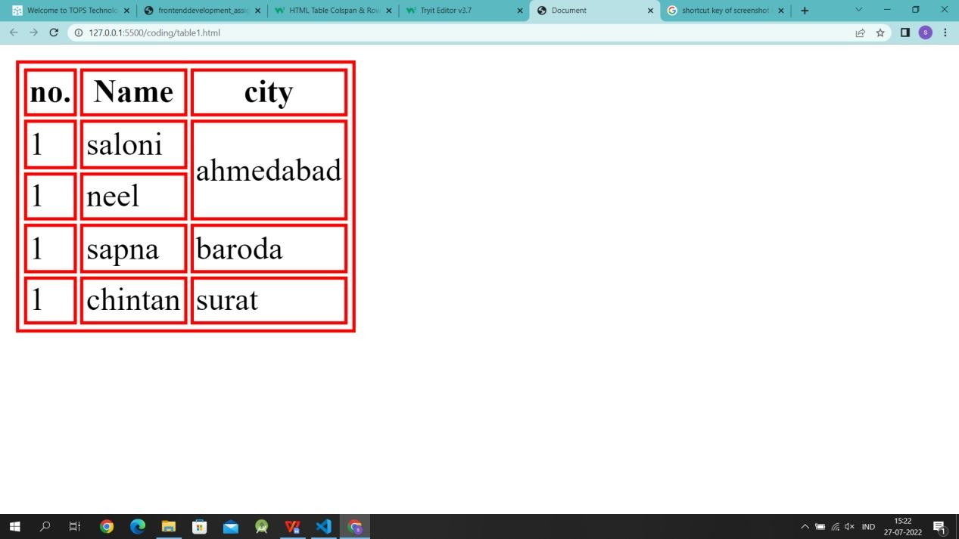

we can club two or more columns using colspan=”” attribute. For example:

<html lang="en">

<head>

<meta charset="UTF-8">

<meta http-equiv="X-UA-Compatible" content="IE=edge">

<meta name="viewport" content="width=device-width, initial-scale=1.0">

<title>Document</title>

</head>

<style>

table, th,

td {

border: 2px solid red;

}

</style>

<body>

<table>

<tr>

<th>no.</th>

<th colspan="2">Name</th>

<th>city</th>

</tr>

<tr>

<td>1</td>

<td>saloni</td>

<td>patel</td>

<td>ahmedabad</td>

</tr>

<tr>

<td>1</td>

<td>neel</td>

<td>patel</td>

<td>rajkot</td>

</tr>

<tr>

<td>1</td>

<td>sapna</td>

<td>prajapati</td>

<td>baroda</td>

</tr>

<tr>

<td>1</td>

<td>chintan</td>

<td>jain</td>

<td>surat</td>

</tr>

</table>

</body>

</html>

Output:

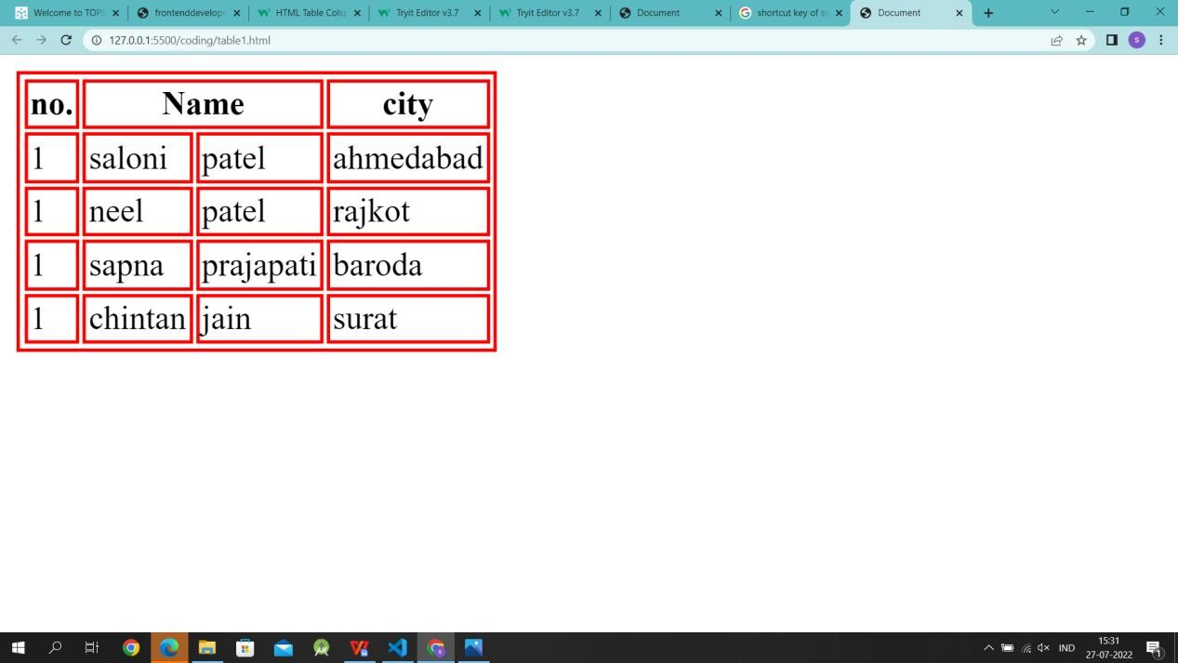

# what is the difference between a block-level element and inline element?

**ANS=** Block Elements occupy the full width. Inline elements don't start in a new line.

Block-level elements example:

<div> <section> <header> <footer> <nav> <table>

<article> <aside> <h1-h6>

Inline element examples:

<b> <i> <em> <img> <strong> <sub> <sup> <small>

1. **How to create a Hyperlink in HTML?**

**ANS=** The HTML <a> tag defines a hyperlink. For example,

<a href=”https://[www.google.com](http://www.google.com/)”>Google</a>

# What is the use of an iframe tag?

**Ans =** An frame is used to display another document in the current HTML document.

**Example:**

<iframe src="/default.asp" width="100%" height="300" style="border:1px solid black;">  
</iframe>  
  
<iframe src="/default.asp" width="100%" height="300" style="border:none;">  
</iframe>

1. **What is the use of a span tag?**

**Ans =** The <span> tag is like the [<div>](https://www.w3schools.com/tags/tag_div.asp) element, but <div> is a block-level element and <span> is an inline element.

**Example:**

<!DOCTYPE html>

<html>

<body>

<h1>The span element</h1>

<p>My mother has <span style="color:blue;font-weight:bold">blue</span> eyes and my father has <span style="color:darkolivegreen;font-weight:bold">dark green</span> eyes.</p>

</body>

</html>

1. **How to insert a picture into a background image of a web page?**

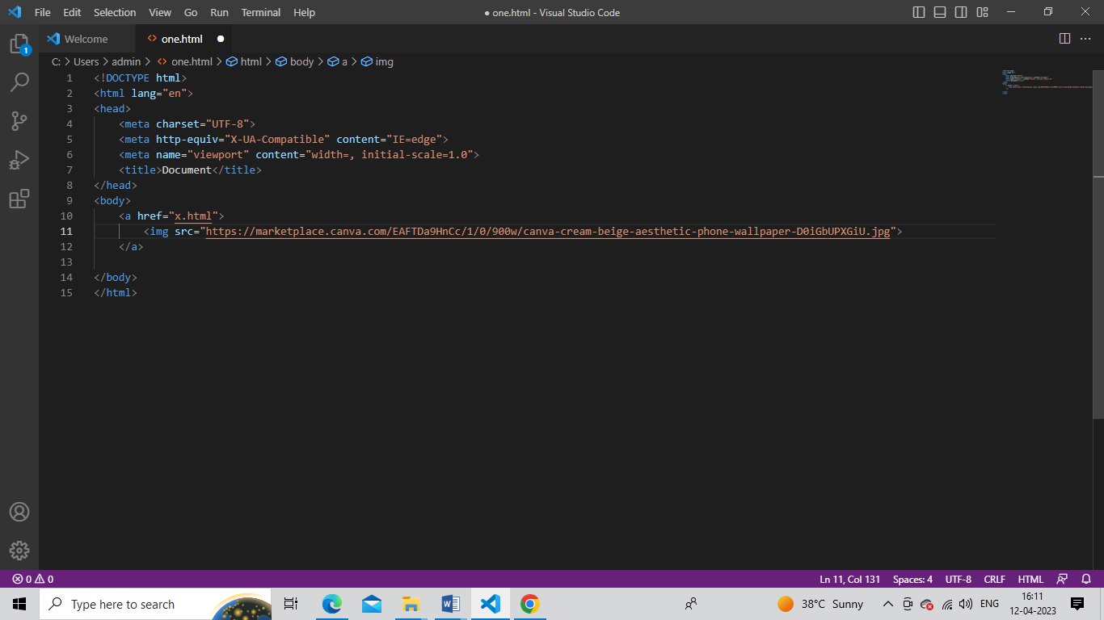

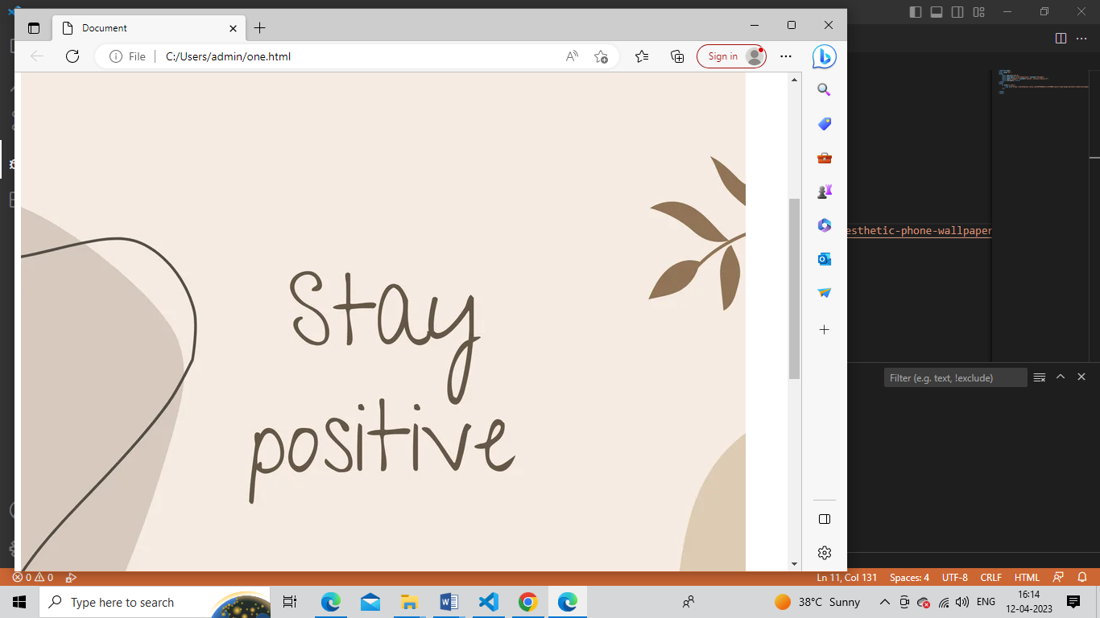

1. **How are active link different from normal link?**

**Ans=** An unvisited link is underlined and purple. An active link is underlined and red.

If you want to create a link to go to “<https://www.geeksforgeeks.org/>“, you can get the normal link through this code. The default color is blue color and underlined but you can apply your own custom styling according to the application’s need.

**Output:**



1. **What are the different tags to separate sections of text?**

**Ans=** <br>tag- it is used to separate the line or text.it breaks the current line and shifts the flow of the text to a new line.

<p>tag- this tag is used to write a paragraph of text.

<blockquote>tag- this tag is used to define large quoted sections.

Layout:

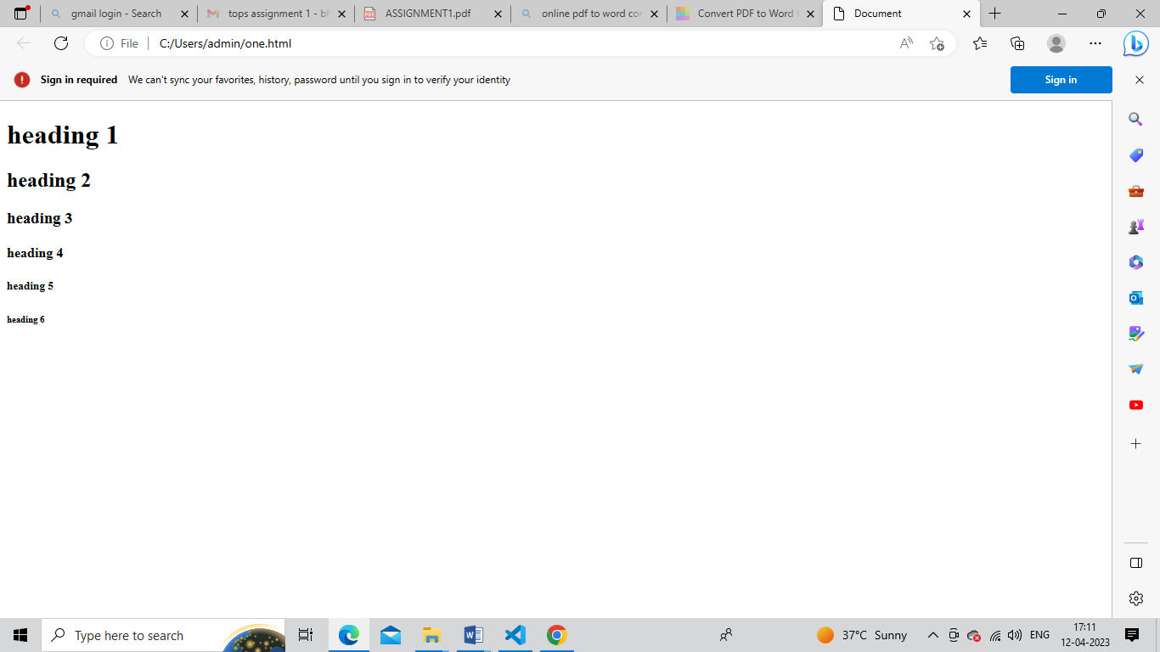

**17.what is difference between HTML and XHTML?**

|  |  |
| --- | --- |
| HTML | XHTML |
| No support for audio and video | Supports high quality audio and video |
| Tags are not extensible | Tags are extensible |
| Tags are not case-sensitive | Only lowercase tags are allowed |
| Possible to leave off and ending tag like </body> | Tags should appear in pairs |
| Overlapping tags | No overlapping tags |

**18.What are logical and physical tags in HTML?**

**Ans=** The example of the logical tag is <strong> </strong>tag. When we enclose the text in the strong tag, it tells the browser that enclosed text is more important than other texts. Physical tags are used to tell the browser how to display the text enclosed in the physical tag.

**The example of the logical tag is** <strong> </strong> tag. When we enclose the text in the strong tag, it tells the browser that enclosed text is more important than other texts.

**Some of the examples of physical tags are** <b>, <big>**, <i>.** <b>, <big>, <i>.